BAIS:3200
Final Project Report
Group 12: Hikaru Carolin, Alexa Martin, Ozan Dogan, Reed Foster, Jenna Grant

Introduction
The NFL Draft took place last week, and previous datasets can help predict how a player will perform based on when they were drafted. The NFL Draft is important for NFL teams because it allows the teams to bring new talent and opportunities into their roster. For this project, our group gathered data from NFL Drafts between 2000 and 2015 in order to understand past patterns and trends of the NFL Draft. Our project will also analyze the most successful members of the drafts, and if the team they were drafted to has an impact on their success. This analysis can be helpful for NFL players, NFL teams, and football enthusiasts looking for more information about the draft.

Data
This project uses data gathered from a Kaggle dataset about NFL players draft information and their overall performance in the NFL (https://www.kaggle.com/datasets/ulrikthygepedersen/nfl-draft-1985-2015). The dataset includes NFL drafts from the years of 1985 to 2015, but our group only used data from 2000 – 2015, due to how much the game of football has changed since the mid-1980s. This dataset originally included 4,079 responses and 34 categories, but our group narrowed the data to 35 categories to analyze the most relevant fields of information and have included fields for team information and created a primary identifier for colleges. The most relevant information is player description, the draft pick, and statistics while in the NFL. The player description will give us unique player identifications, while the data of the draft pick and statistics of the player in the NFL will help our group analyze information about the NFL Draft and the success of players being picked. Table 1 displays a description of the data.

Table 1 Data dictionary
Field | Type | Description
PlayerID | Text | Unique ID for each player
Draft_Year | Numeric | The year the player was drafted
Round | Numeric | The round the player was drafted in
Draft_Pick | Numeric | The pick the player was selected with
TeamID | Text | Unique ID for each team
Team | Text | The team the player was drafted to
Year_Founded | Number | The year the team was founded
SB_Appearances | Number | The number of times the team has made the Super Bowl
SB_Wins | Number | The number of times the team has won the Super Bowl
First_Name | Text | The player's first name
Last_Name | Text | The player’s last name
Position | Text | The player's specific position
Position Standard | Text | The player's standardized position
Age | Numeric | The player's age when drafted
Played Until | Text | The year the player played until (up to 2016), players who never played in an NFL game are listed as “DNP” (Did not play)
First Team All-Pro | Numeric | The number of times the player was named First Team All- Pro
Pro Bowl | Numeric | The number of times the player was selected for the Pro Bowl
Games_Started | Numeric | Number of games the player was his team's starter
Games Played | Numeric | The total number of games the player played in
Completions | Numeric | Number of total pass completions
Pass_att | Numeric | Number of passing attempts
Pass_Yds | Numeric | Number of passing yards
Pass_Td | Numeric | Number of passing touchdowns
Pass_Int | Numeric | Number of interceptions thrown
Rush_Att | Numeric | Number of rushing attempts
Rush_Yds | Numeric | Number of rushing yards
Rush_Td | Numeric | Number of rushing touchdowns
Receptions | Numeric | Number of receptions
Rec_Yds | Numeric | Number of receiving yards
Rec_Tds | Numeric | Number of receiving touchdowns
Tackles | Numeric | Number of tackles
Def_Int | Numeric | Number of defensive interceptions
Sacks | Numeric | Number of defensive sacks
CollegeID | Text | Unique ID for each college a player was drafted out of
College | Text | The college the player was drafted out of

The PLAYER entity is uniquely identified by PlayerID. The PLAYER entity also displays the player’s first and last names, games started and played, as well as various other stats related to performance. These stats are not all applicable for every player, as they vary by each player’s position. The DRAFT entity holds the draft details of each player including the PlayerID DraftYear and DraftPick which act as the composite primary key. Other information includes the round, position, position_standard and age. The COLLEGE Tables unique identifier is CollegeID and the name of the college. The fourth entity, TEAM is uniquely identified by TeamID. In the database, each team has its name, when they were founded, and their Superbowl appearances and wins. Figure 1 displays the Entity Relationship Diagram for this data.
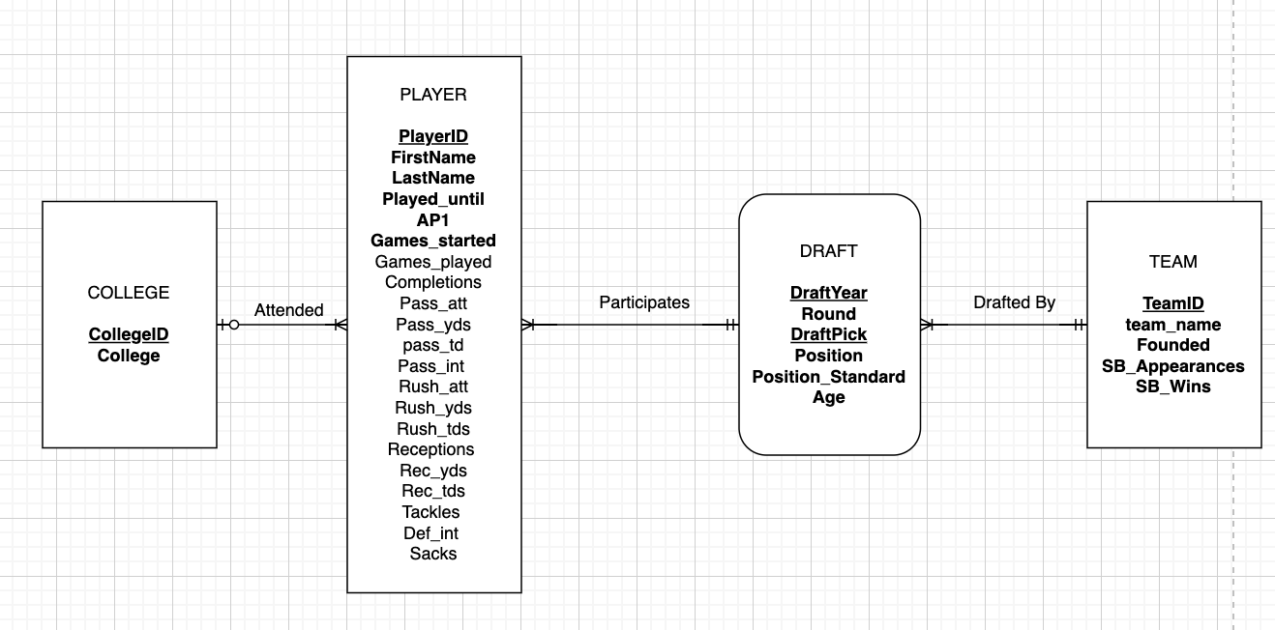
Figure 1 – Entity Relationship Diagram (ERD)
Based on this ERD, we normalized the data and created a relational schema with 4 tables. Figure 2 displays the graphical relational schema of our NFL Draft database. The COLLEGE table acts as a parent table to PLAYER, where CollegeID is a foreign key in the PLAYER table. The PLAYER table and the TEAM table act as parent tables for the DRAFT table where PlayerID from the PLAYER table is part of the composite primary key for the DRAFT table, and TeamID from the TEAM table is a foreign key in the DRAFT table.

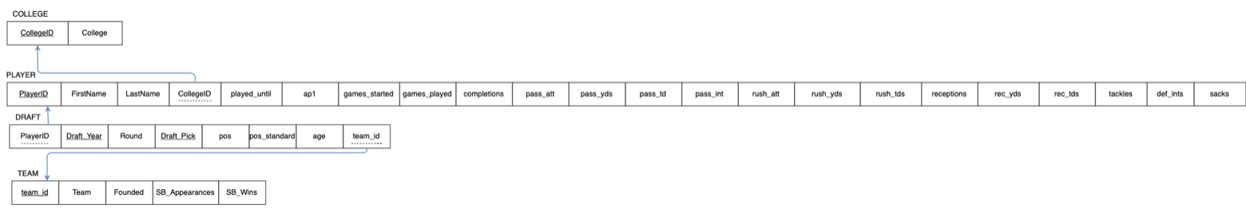
Fig. 2 Graphical relational schema

Database Implementation
To implement the database into Oracle APEX, we used CREATE table commands to input our 4 tables from the relational schema.

COLLEGE
As a parent table for PLAYER, COLLEGE was created and populated first:

Create Table COLLEGE (
CollegeID VarChar2(5) not null,
College varchar2(50) not null,
Constraint College_PK Primary Key (CollegeID));

INSERT INTO COLLEGE VALUES (‘ORE’, ‘Oregon’);

TEAM
As one of the parent tables for DRAFT, TEAM was created and populated second :

Create Table TEAM (
TeamID Char(3) not null,
Team_Name VarChar2(11) not null,
Founded Number (4,0) not null,
SB_Appearances Number (*,0) not null,
SB_Wins Number (*,0) not null,
Constraint TEAM_PK Primary Key (TeamID));

INSERT INTO TEAM VALUES (‘TAM’, ‘Buccaneers’, 1976, 1, 1);

*Note: The order in which the COLLEGE and TEAM table were created and populated are interchangeable

PLAYER
Being a parent table for DRAFT, the PLAYER table must be created and populated before the DRAFT table but after the COLLEGE table:
CREATE TABLE PLAYER (
PlayerID VARCHAR2(20) NOT NULL,
Firstname VARCHAR2(25) NOT NULL,
Lastname VARCHAR2(25) NOT NULL,
CollegeID VARCHAR2(5) NOT NULL,
Played_Until VARCHAR2(4) DEFAULT 'DNP',
ap1 NUMBER(2,0) NOT NULL,
pro_bowl NUMBER(2,0) NOT NULL,
Games_Started NUMBER(*,0) NOT NULL,
Games_Played NUMBER(*,0) DEFAULT 0,
Completions NUMBER(*,0) DEFAULT 0,
Pass_att NUMBER(*,0) DEFAULT 0,
pass_yds NUMBER(*,0) DEFAULT 0,
pass_td NUMBER(*,0) DEFAULT 0,
pass_int NUMBER(*,0) DEFAULT 0,
rush_att NUMBER(*,0) DEFAULT 0,
rush_yds NUMBER(*,0) DEFAULT 0,
rush_tds NUMBER(*,0) DEFAULT 0,
receptions NUMBER(*,0) DEFAULT 0,
rec_yds NUMBER(*,0) DEFAULT 0,
rec_tds NUMBER(*,0) DEFAULT 0,
tackles NUMBER(*,0) DEFAULT 0,
def_int NUMBER(*,0) DEFAULT 0,
sacks NUMBER(*,0) DEFAULT 0,
CONSTRAINT PLAYER_PK PRIMARY KEY (playerid),
CONSTRAINT PLAYER_FK FOREIGN KEY (CollegeID) REFERENCES COLLEGE (CollegeID));

INSERT INTO PLAYER (PlayerID, Firstname, Lastname, CollegeID, Played_Until, ap1, pro_bowl, Games_Started, Games_Played, Completions, Pass_att, pass_yds, pass_int, rush_att, rush_yds, rush_tds) VALUES (‘WinsJa00’, ‘Jameis’, ‘Winston’, ‘FSU’, ‘2016’, 0, 1, 2, 26, 540, 913, 6722, 42, 25, 86, 311, 7);

DRAFT
CREATE table DRAFT (
PlayerID VARCHAR2(20) not null,
Draft_Year Number(4,0) not null check (Draft_Year > 1999 AND Draft_Year < 2016),
Draft_Round Number (1,0) not null,
Draft_Pick Number (3,0) not null,
TeamID Char(3) not null,
Position VarChar2(3) not null Check (position in ('QB','OLB','WR','T','DE','RB','CB','NT','DT','C','G','FS','ILB','SS','TE','FB','S','P','LS','LB','OL','DB','K','DL')),
Position_Standard Varchar2(2) not null check (position_standard in ('QB','LB','WR','T','DE','RB','DB','DT','C','G','TE','FB','P','LS','K')),
Age Number (2,0) not null,
Constraint DRAFT_PK Primary Key (PlayerID, Draft_Year, Draft_Pick),
Constraint DRAFT_Player_FK Foreign Key (PlayerID) References PLAYER (PlayerID),
Constraint DRAFT_Team_FK Foreign Key (TeamID) References TEAM (TeamID));

INSERT INTO DRAFT VALUES (‘WinsJa00’, 2015, 1, 1,‘TAM’, ‘QB’, ‘QB’, 21);

Analysis
This analysis is intended to identify specific relationships and information relating to NFL Draft data by identifying key statistics related to draft picks per team, the average games played by first round draft picks, the most picked position each year, the player with the most rushing yards, and quarterback performance.

Question 1: Draft Picks Per Team
What is the total number of draft picks made by each team between the years 2000 and 2015? To answer this research question, our group created a JOIN Query that counts the number of draft picks per team each year. From there the query creates a total the number of picks, between 2000 and 2015, and lists from highest to lowest amount.
SELECT TEAM.Team_Name, COUNT(DRAFT.Draft_Pick) AS Total_Draft_Picks
FROM TEAM
JOIN DRAFT ON TEAM.TeamID = DRAFT.TeamID
WHERE DRAFT.Draft_Year BETWEEN 2000 AND 2015
GROUP BY TEAM.Team_Name
ORDER BY Total_Draft_Picks DESC;

The table produced as a result of the query is shown below. From the table, we were able to conclude that the 49ers were the team with the greatest number of picks, 146. The Saints were the lowest with only 107 picks between 2000 and 2015. While this query returns 32 rows, the first 18 are shown below (Fig. 3):
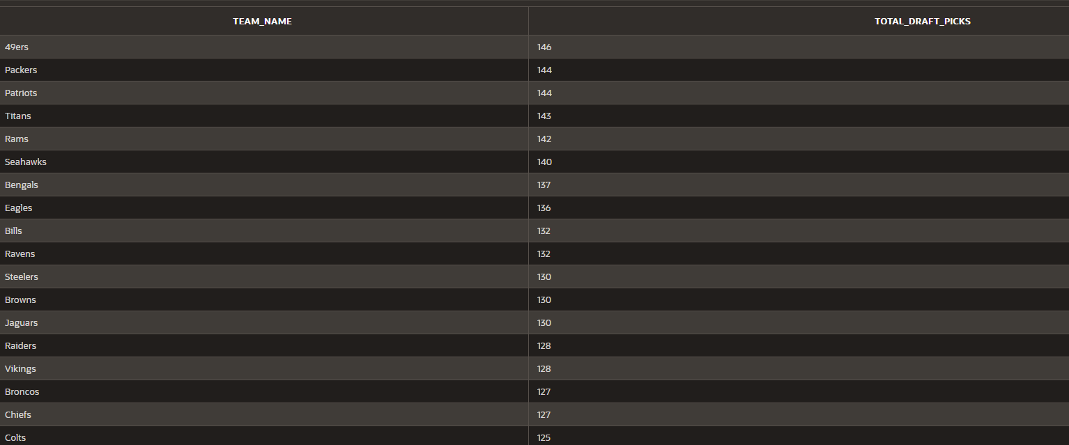
Fig. 3: Most Draft Picks
Question 2: Average Games Played by First Round Draft Picks
What is the number of games played by first round draft picks from 2000-2015? This question can be answered with a GROUP BY query that returns each first round draft picks name, the NFL team, and the number of games played. This can help analyze whether there is a pattern between being a first-round draft pick and averaging a higher number of games.
SELECT Team_Name, Firstname, Lastname, AVG(Games_Played) as Avg_Games_Played
FROM PLAYER
JOIN DRAFT ON PLAYER.PlayerID = DRAFT.PlayerID
JOIN TEAM ON DRAFT.TeamID = TEAM.TeamID
WHERE Draft_Round = 1 AND Draft_Year BETWEEN 2000 AND 2015
GROUP BY Team_Name, Firstname, Lastname
ORDER BY Avg_Games_Played;

The table’s results are shown below, and it can be concluded that the Bears first-round pick Kevin White played in the least number of games (4 games), while the Raiders first-round pick Sebastian Janikowski played in the most amount of games (262). This data can also help find a pattern if a team has multiple players with high or low numbers of games which can help the team strategize for future drafts. (Fig 4.)
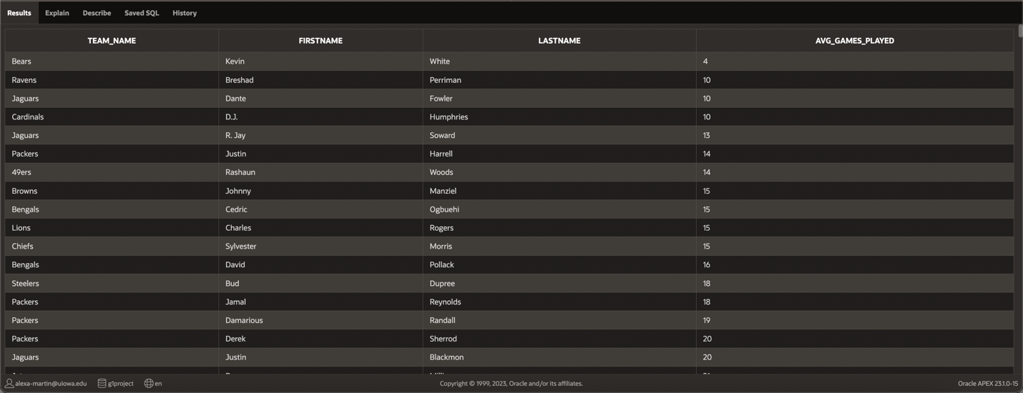
Fig. 4: Average Games played
Question #3: Most Picked Position each Year
What are the most common positions picked in the NFL draft and how has this changed over time? To answer this question, our group constructed a SQL query that retrieves data from the DRAFT table. This query uses a GROUP BY clause to group the data by "draft_year" and "position," and a subquery to find the maximum count of players drafted for each year. The HAVING clause filters the results to only show the most picked position(s) for each year, and the ORDER BY clause sorts the results in ascending order by draft year. Overall, this query allows us to analyze the data and identify the most commonly picked positions in the NFL draft over time, providing insights into draft trends and strategies.

SELECT draft_year as Year, position, COUNT(*) AS Drafted
FROM DRAFT
GROUP BY draft_year, position
HAVING COUNT(*) = (
SELECT MAX(cnt)
FROM (
SELECT draft_year, position, COUNT(*) AS cnt
FROM DRAFT
GROUP BY draft_year, position) t
WHERE t.draft_year = DRAFT.draft_year)
ORDER BY draft_year ASC;

The query’s results are shown in the table below. From the table, it can be concluded that the most picked position in the NFL draft between the years 2000 to 2015 was Defensive Back (DB). This position was most picked in every year except 2015, when Wide Receiver (WR) became the most picked position. The fact that WR was the most picked position in 2015 suggests a shift in the league's offensive strategies and the increasing emphasis on passing the ball. Although the query returns 16 rows, only the first 14 are shown below (Fig. 5).
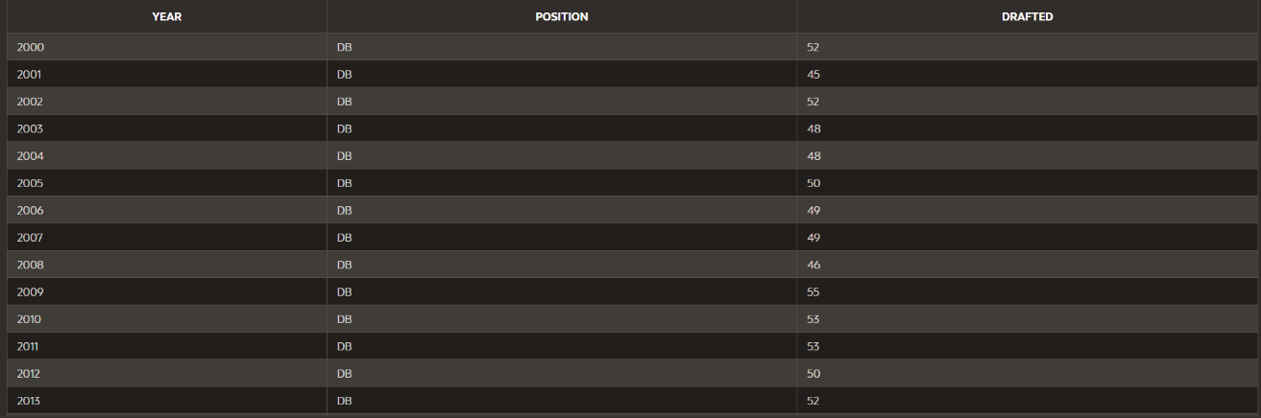
Fig. 5: Most Picked Positions

Question #4: Player with most rushing yards
Which running back drafted between the years 2000 and 2015 had the most rushing yards? To answer this question, our group created a SELECT query that retrieves data from the PLAYER and DRAFT tables by joining them under the common column, PlayerID. This specific query is a complex SELECT statement that includes both JOIN and subquery attributes as well as a MAX function to return the result.

SELECT FirstName, LastName, rush_yds as "Rushing Yards"
FROM PLAYER
JOIN DRAFT ON PLAYER.PlayerID = DRAFT.PlayerID
WHERE DRAFT.Draft_Year BETWEEN 2000 AND 2015 AND rush_yds = (SELECT MAX(rush_yds) FROM PLAYER)
FETCH FIRST 1 ROWS ONLY
;

The table’s results show that LaDainian Tomlinson has the most rushing yards of running backs from the NFL draft between the years of 2000 and 2015. (Fig. 6)

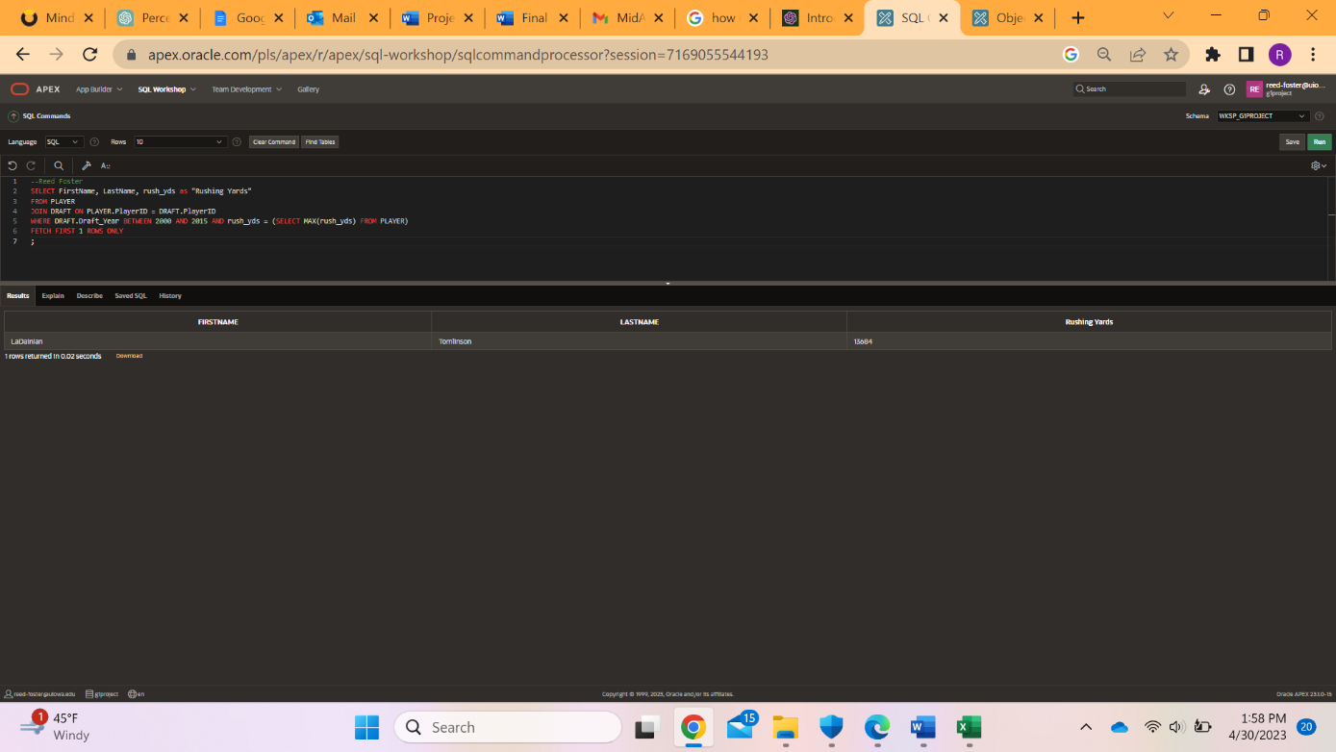
Fig. 6: Most rushing yards

Question #5: Quarterback Performance
Which quarterbacks drafted between 2000 - 2014 have had some of the best careers? Can we use passing yards per season and touchdown/interception ratios to determine which QBs with at least 100 pass attempts have been the most successful? With it being difficult to determine a quarterback's skill after just one year, QBs who played only one season are not included. To exclude quarterbacks that have only played for one or zero seasons, we cast played_until as an integer, and excluded quarterbacks who were in the league for one year or did not play. We included the quarterbacks who had a TD/Int ratio above the average for the dataset. (Fig. 7)

SELECT firstname, lastname, draft_year, ROUND((pass_yds / (CAST(played_until AS INTEGER) - draft_year)), 1) AS yards_per_season, (pass_td ||'/'|| pass_int) AS td_int_ratio
FROM player
JOIN draft ON player.playerid = draft.playerid
WHERE played_until <> 'DNP'
HAVING (CAST(played_until AS INTEGER) - draft_year) > 1 and pass_att > 100
AND pass_td / pass_int >
(SELECT AVG(pass_td) / AVG(pass_int) FROM player)
GROUP BY firstname, lastname, draft_year, pass_yds, pass_att, played_until, pass_td, pass_int;

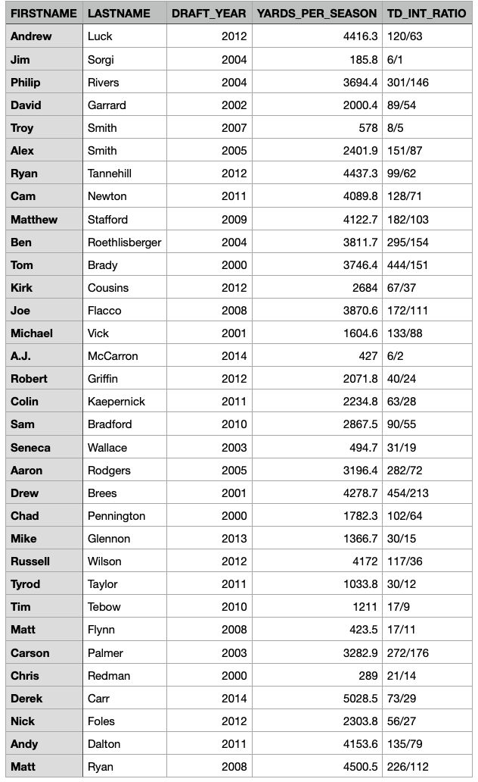
Fig 7: Top QB Careers
The results of the query return many household names that have been successful in the league. Despite there being 198 QBs in this dataset, this query only returned 27 players, which displays how hard it is for a quarterback to succeed in this league. It also shows that many QBs do not even get to throw 100 passes, which is reassuring to the players who begin to lose confidence in themselves as a starter, showing them that only a few are even above the average of touchdown/interception ratios.

Web Design:
Oracle Application Public Link: https://apex.oracle.com/pls/apex/r/g1project/nfl-data-final-project-application/home?session=114924929818165
Home Page
The home page of our application includes a brief introduction as to what our application is about and the dataset that we used from Kaggle and a Creative Commons-licensed image of the NFL draft logo (https://en.wikipedia.org/wiki/National_Football_League_Draft). It highlights the importance of the data we collected, and the different ways real NFL analysts can collect data about the draft. We wanted to give users a look inside the relevance of our data while also catching their attention! Figure 8 shows a screenshot of the home page.
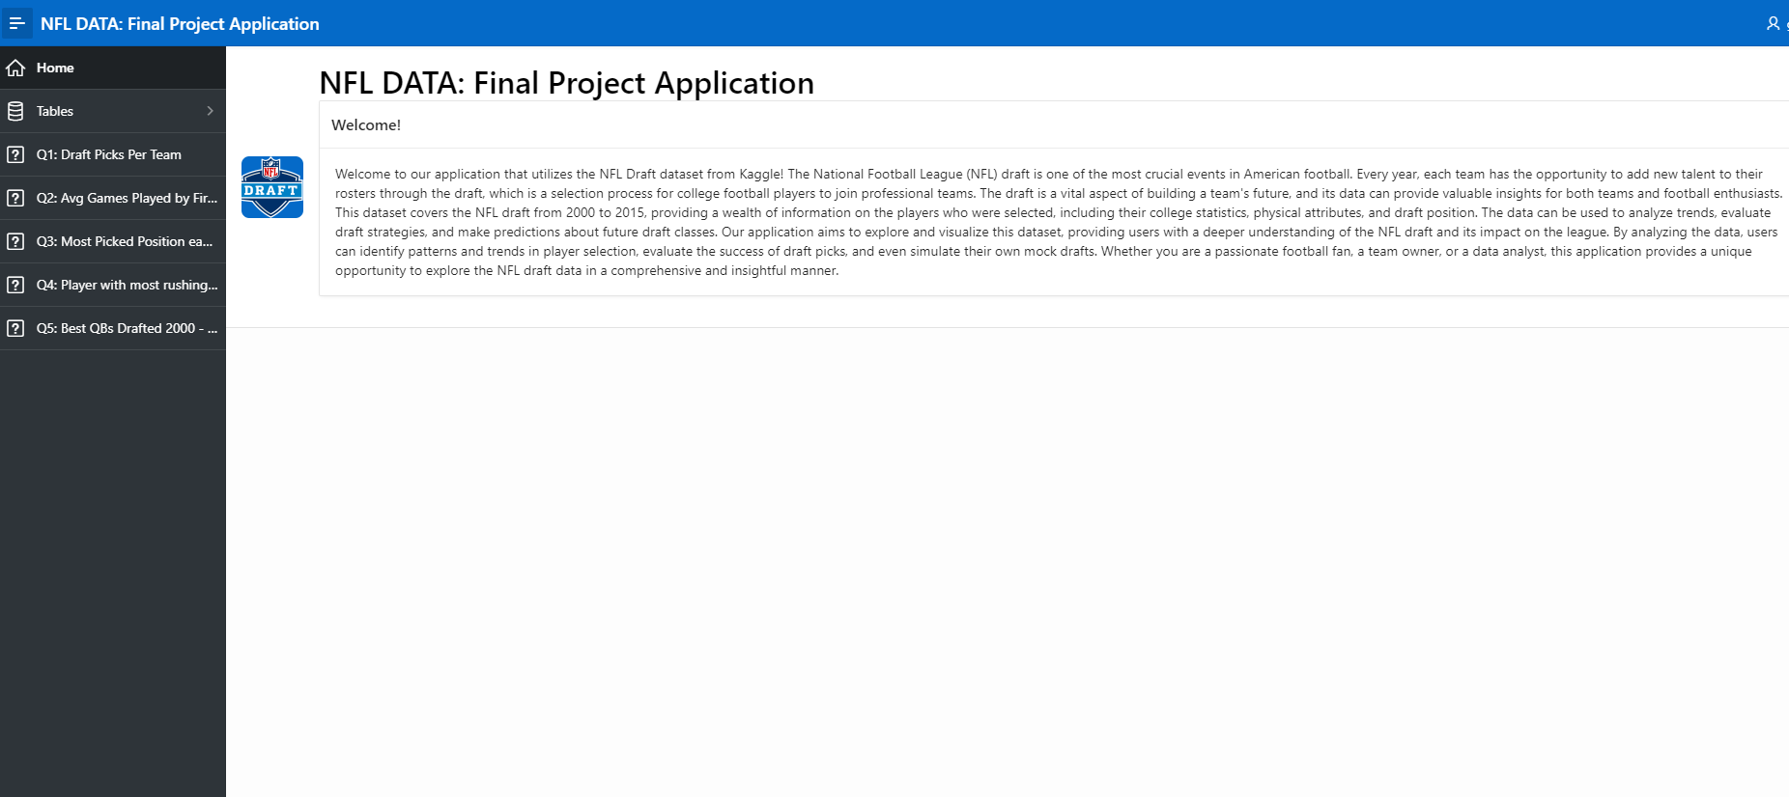
Fig. 8 Home Page

Tables
Within the database we made tables to explain the data that factors into our analysis and reports. Using these tables, it is easy to find and sort through the data to fully comprehend our analysis of the NFL draft data which can help to find patterns in past and future drafts. Using these tables, we can create other pages to answer the questions that we have asked about the NFL draft. Our table pages also have a description for easy understandability for users looking at the webpage.
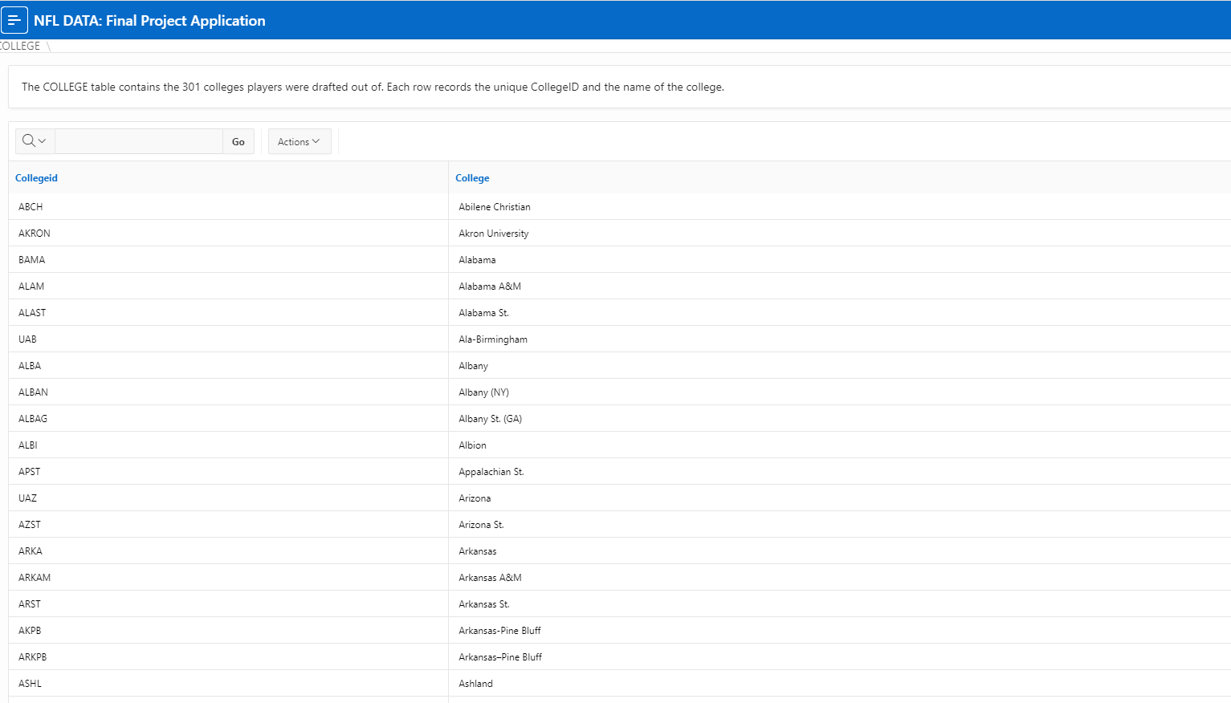
Fig. 9 COLLEGE
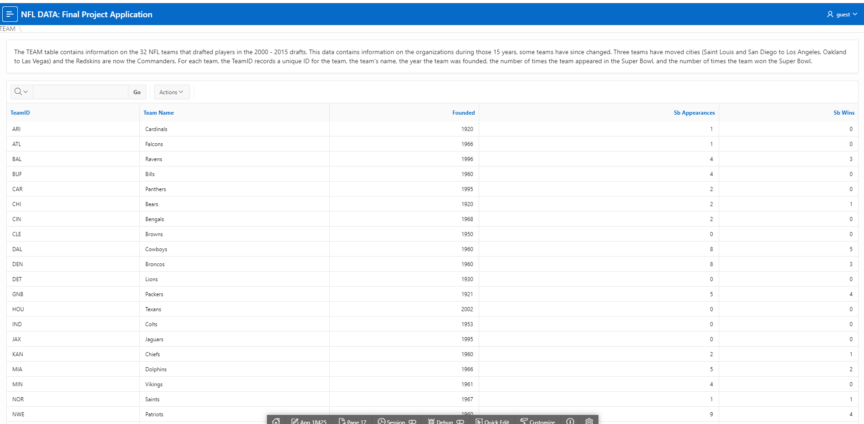
Fig. 10 TEAM

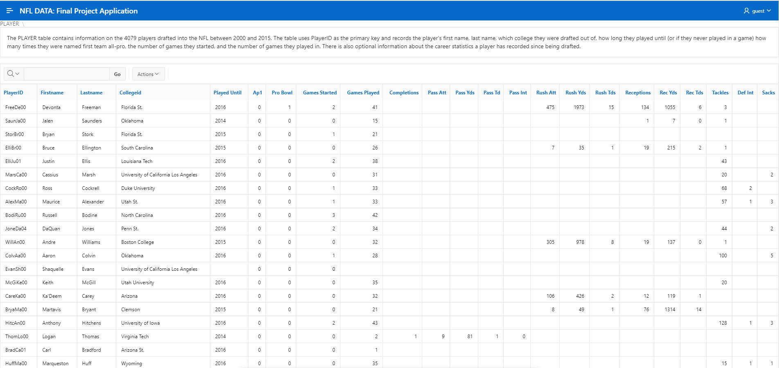
Fig.11 PLAYER
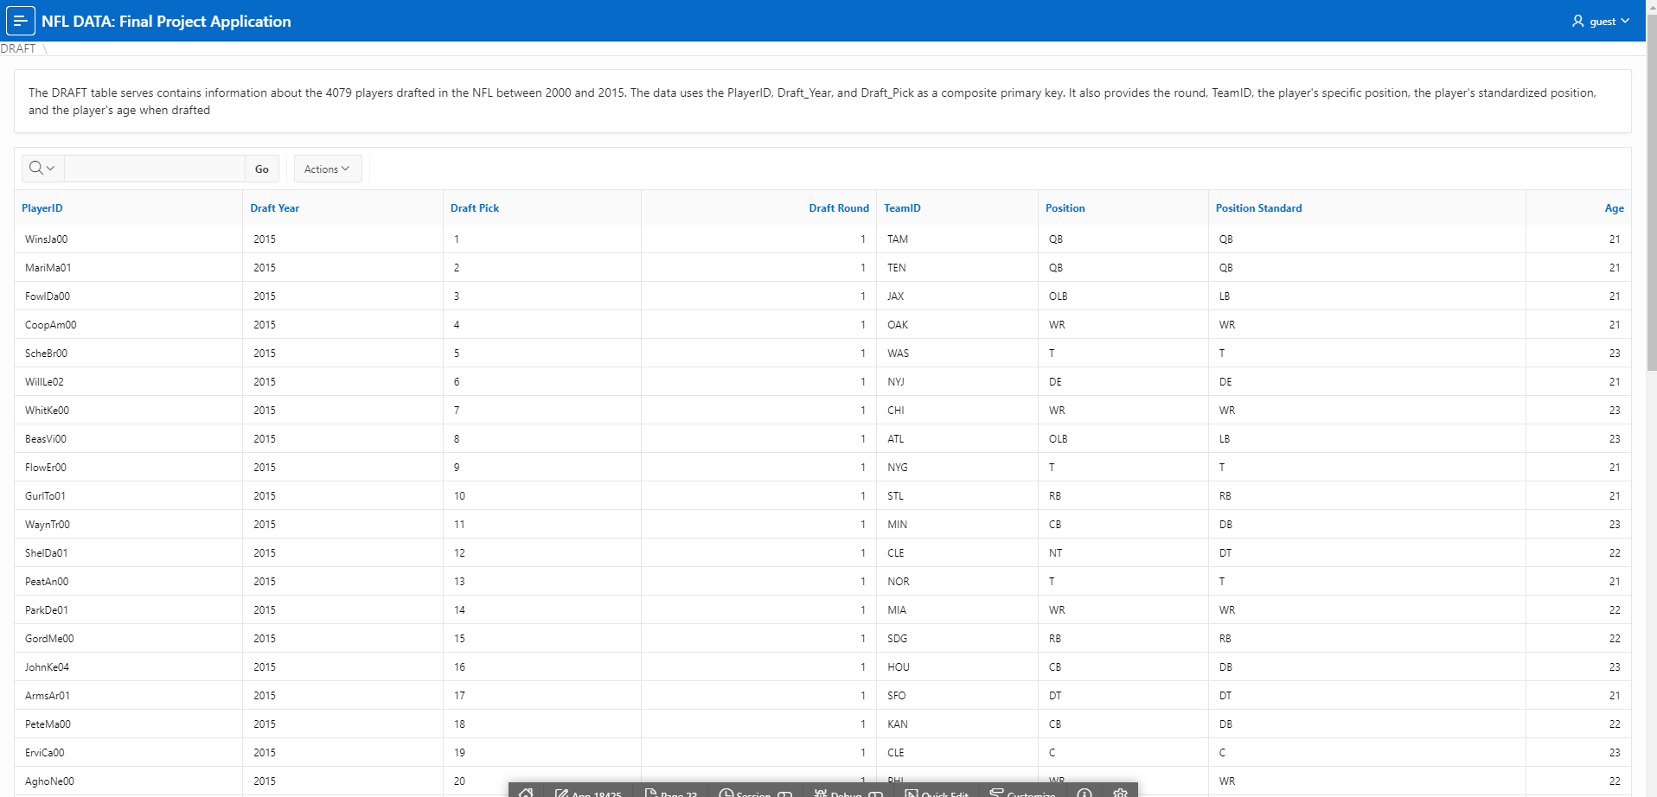

Fig. 12 DRAFT

Queries
Question 1: The first question in our application shows the total number of picks each team in our database accumulated from 2000 to 2015. I displayed the results of the query in a classic report as well as an accompanied bar chart. On each of our questions we added a text box to restate the research question and the general results of each query. In my results section, I included the teams with the highest number as well as the least number of picks during the time period. This page is shown below in Figure 13.

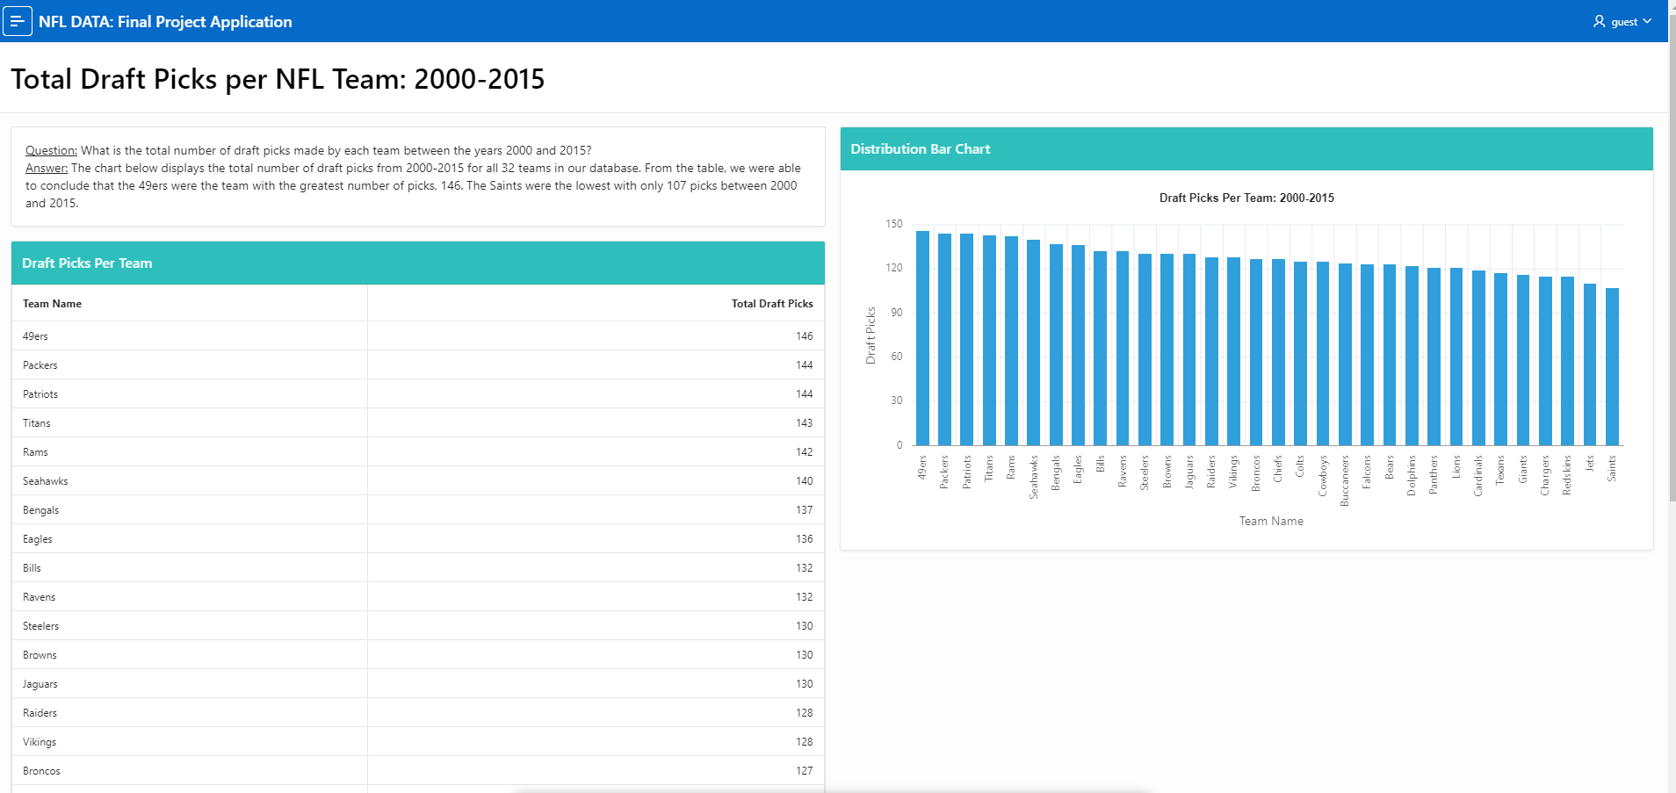
Fig. 13 TOTALPICKS
Question 2:
What is the number of games played by first round draft picks from 2000-2015? Which teams will have the most first-round draft picks playing on their team? Will this help them strategize for the draft in upcoming seasons? The table’s results are shown in figure label (Fig 14), and it can be concluded that the Bears first-round pick, Kevin White, played in the least number of games (4 games), while the Raiders first-round pick, Sebastian Janikowski, played in the most amount of games (262). This data can also help find a pattern if a team has multiple players on certain teams with high or low numbers of games which can help the team strategize for future drafts.

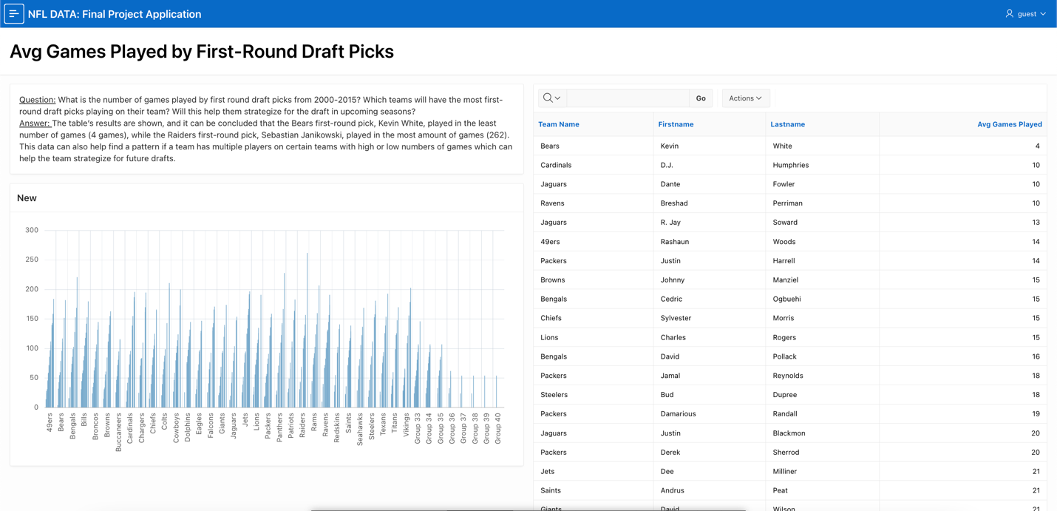
Fig. 14: Average Games Played by First-Round Draft Picks

Question 3:
What are the most common positions picked in the NFL draft and how has this changed over time? The query’s results are shown in the table below in figure 15 (Fig 15). From the table, it can be concluded that the most picked position in the NFL draft between the years 2000 to 2015 was Defensive Back (DB). This position was most picked in every year except 2015, when Wide Receiver (WR) became the most picked position. The fact that WR was the most picked position in 2015 suggests a shift in the league's offensive strategies and the increasing emphasis on passing the ball.
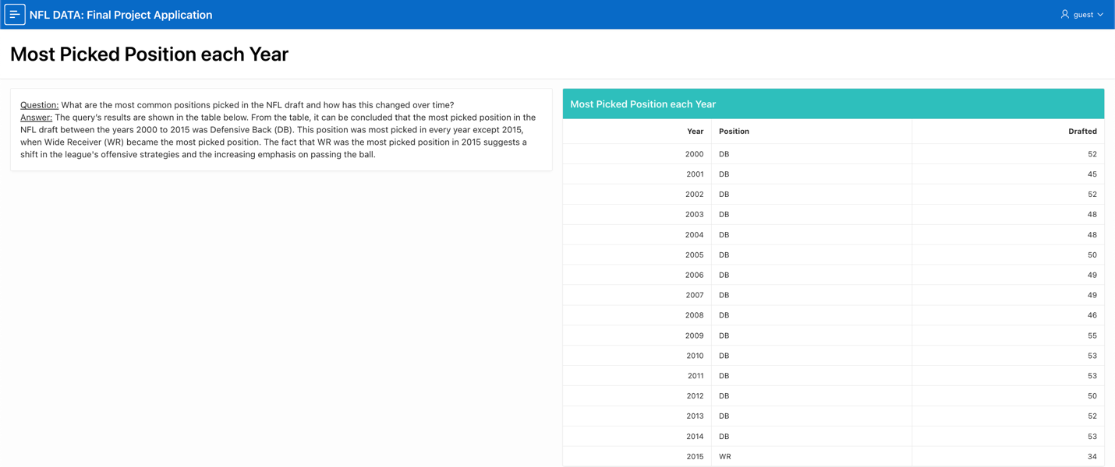
Fig. 15: Most Picked Position Each Year

Question 4:
Which running back drafted between the years 2000 and 2015 had the most rushing yards? To answer this question, our group created a SELECT query that retrieves data from the PLAYER and DRAFT tables by joining them under the common column, PlayerID. This specific query is a complex SELECT statement that includes both JOIN and subquery attributes as well as a MAX function to return the result. The table’s results show that LaDainian Tomlinson has the most rushing yards of running backs from the NFL draft between the years of 2000 and 2015 in figure 16 (Fig 16).
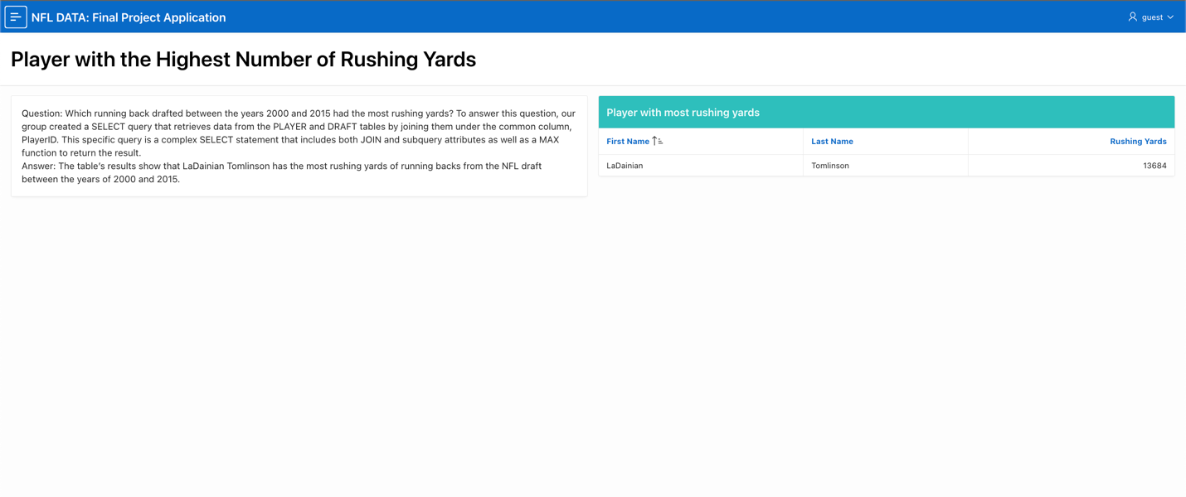
Fig. 16: Player with the Highest Number of Rushing Yards

Question 5:
The final research question concerns which quarterbacks that were drafted between 2000 – 2015 have had the best performances in their careers. The charts are split between the top five quarterbacks with the highest average passing yards per season highest TD/INT ratio. We first chose quarterbacks who have played more than one season, have thrown at least 500 passes, and who have touchdown-to-interception ratios that are higher than the average for all quarterbacks. Results were presented as a classic table and as two interactive charts (Figure 17a and 17b).

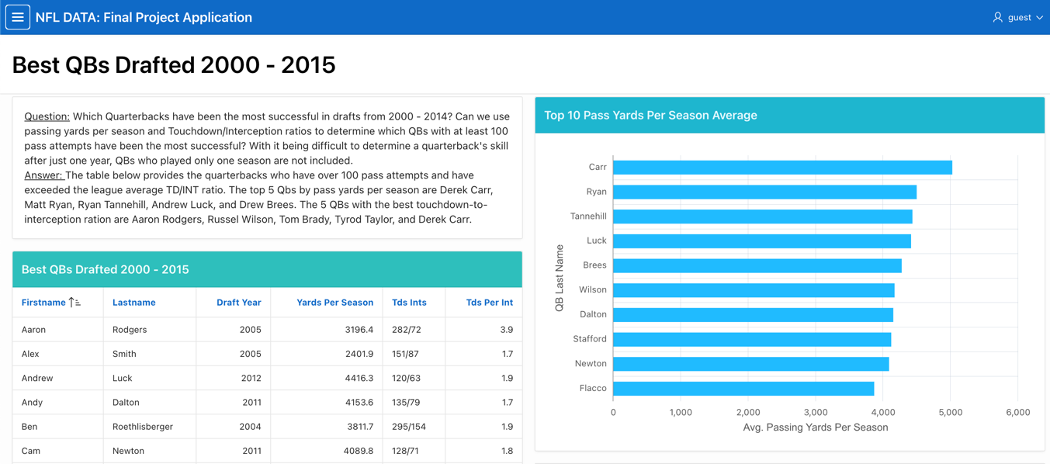
Fig. 17a Best QBs: Pass Yards per Season

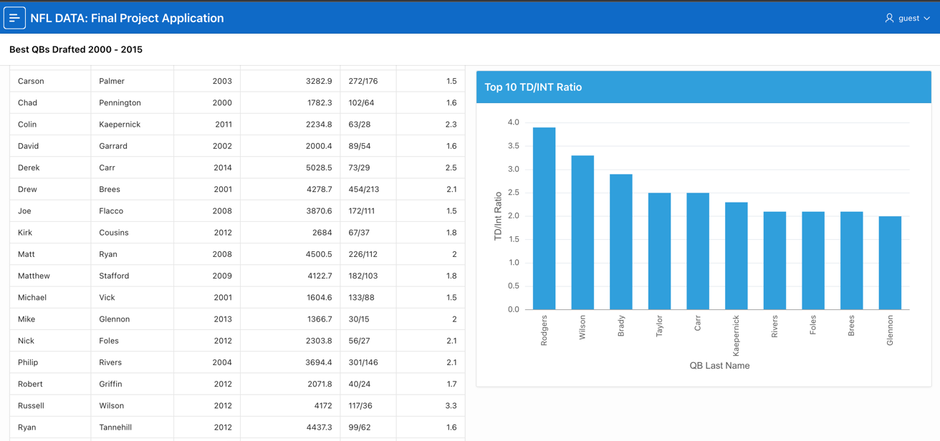

Fig. 17a Best QBs: Touchdown-to-Interception Ratio

